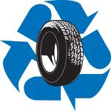

Tire Recycle

Who: All Troy-Jay Residents & Businesses

When: Friday, Sept 19 Noon - 3 pm
Saturday, Sept 20 9 am to Noon

Where:
Troy/Jay Recycle Center, Cross Road, Jay VT

Tire Size:
Car & Pickup 22” & smaller
Larger than 22” additional fees apply

Cost:
No rim:$3.00 per tire up to 8 tires (Jay-Troy Residents)
$6.00 per tire (Non Troy-Jay Residents)
W/rim: $6.00 per tire (Jay-Troy Residents)
$10.00 per tire (Non Jay Troy Residents)

Cash or Check made out to Town of Troy
Questions? Call Dave at 988-4193
or Troy Town Clerk at 988-2663

